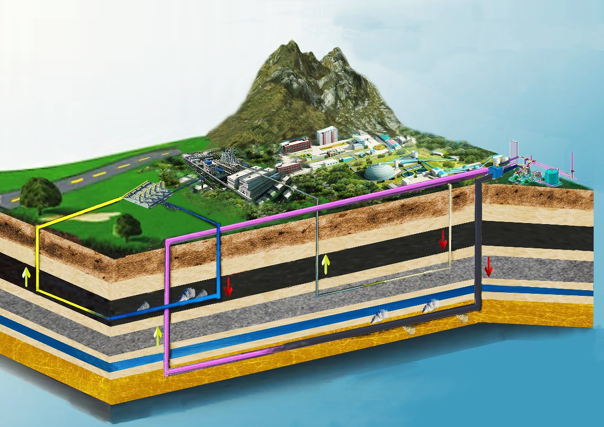International Symposium on In-situ Modification of Deposit Properties for Improving Mining (IMDPIM)
---Secondround announcement---

第一届原位改性采矿国际研讨会
---2号通知---

The International Symposium on In-situ Modification of Deposit Properties for Improving Mining (IMDPIM) will be held on 18th-20thSeptember 2018 in Taiyuan, Shanxi Province, China. This symposium is hosted by Taiyuan University of Technology andco-organized byKey Laboratory of In-situ Property-improvingMining of Ministry of Education,Key Laboratory of Safe and Efficient Mining of Mineral Resources of Shanxi Province, Resource and Environment Committee of National Science and Technology Innovation Leading Personnel Alliance andShanxi Society ofRock Mechanics and Rock Engineering. The symposium aims to bring together academic scientists, researchers and research scholarsacross the world wholead the development of geo-energy and geo-resources to exchange and share their new insightsand new achievementsin the theory and technology of geo-energy and geo-resource exploitation.
The symposium themeis "Present Situation and Development of Theory and Technology of In-situ Modification of Deposit Properties for Improving Mining". IMDPIMis aimed ataccomplishingthe targets of safe, efficient and green mining of underground mineral resources such as coal, salt mine, oil shale, nonferrous metal ore and radioactive mineral resources and other resources and energyviamodifyingphysical and/or chemical propertiesof these deposits byin-situ technology of injecting heat, gas, fluid into deposits, by fracking and slotting. The symposiumwill invite international famous expertsas keynote speakers. The meeting will also launch different sessions to discuss the related hot topics.
原位改性采矿国际研讨会将于2018年9月18至20日在山西太原召开。本次会议由太原理工大学主办，原位改性采矿教育部重点实验室、矿产资源安全高效开采山西省重点实验室、全国科技创新领军人才联盟资源与环境专业委员会和山西省岩石力学与工程学会协同承办。会议旨在汇集引领地球能源与资源开发相关领域的国内外研究人员进行交流和分享在地球资源与能源开采理论与技术研究中的新见解和新成果。
本次研讨会的主题为“原位改性采矿理论与技术现状及发展”。原位改性采矿针对地下煤炭、盐矿、油页岩、有色金属矿及放射性矿产资源等资源与能源，通过注热、气、液及水力压裂、割缝等技术，使资源与能源原位赋存特性发生物理、化学变化，从而实现安全、高效、绿色开采目标。大会邀请国内外原位改性采矿领域知名专家作特邀报告，设相关的专题报告，并就其热点议题展开讨论。
Main topics：
1）Experiments, law andtheory of rock mass porous media evolution and multiphase flow;
2）Experimentsandtheory of the THMC coupling effects in rocks;
3）In-situ modifiedminingexperiments,theory and technology of coalbed methane, shale gas, oil shale, gas hydrate and other oil & gas resources;
4）Fluidization and cleaning miningexperiments,theory and technology of coal resources;
5）Theory and technology of artificial reservoir construction in exploring dry hot rock geothermal energy;
6）Theory and technology of salt depositsolution mining and oil & gas storage construction;
7）Experiments,theory and technology of leaching mining of nonferrous metal ore;
8）Experiments,theory and technology ofIn-situ modified mining of radioactive mineral resources;
9）Case analysis of the application of in-situ modified mining technology
本次会议主要议题：
1）岩体多孔介质演化及多相渗流实验、规律及理论；
2）岩石THMC耦合作用实验与理论；
3）煤层气、页岩气、油页岩、甲烷冰等油气资源的原位改性开采实验、理论与技术；
4）煤炭资源流体化清洁开采实验、理论与技术；
5）干热岩地热能开采中人工储留层建造理论与技术；
6）盐类矿床水溶开采与油气储库建造理论与技术；
7）有色金属矿溶浸开采实验、理论与技术；
8）放射性矿产资源原位改性开采实验、理论与技术；
9）原位改性采矿技术应用案例分析
Sponsor:Taiyuan University of Technology
Organizer:
Key Laboratory of In-situ Property-improving Mining of Ministry of Education
Key Laboratory of Safe and Efficient Mining of Mineral Resources of Shanxi Province
Resource and Environment Committee of National Science and Technology Innovation Leading Personnel Alliance
Shanxi Society of Rock Mechanics and Rock Engineering
主办单位：太原理工大学
承办单位：原位改性采矿教育部重点实验室
矿产资源安全高效开采山西省重点实验室
国家科学与技术创新领先人才联盟资源与环境委员会
山西省岩石力学与工程学会
Time and Venue
Time: September 18th-20th, 2018
Venue:Bingzhou Hotel, Taiyuan, Shanxi, China
大会时间与地点
大会时间：2018年9月18日-20日
大会地点：中国·山西·太原·并州饭店
Academic Committee
Director: Yang-sheng Zhao
Members:(Alphabetical order of surname)
Giovanni Barla Maurice B. Dusseault Stephane Bordas Derek Elsworth
Satya HarpalaniYujing Jiang Praveen Linga Ji-shan Liu
Shi-min Liu Ranjith P.G. Kyuro Sasaki Hui-lin Xing
De-xinDing Zeng-chao Feng Yao-qing HuJian-hua LiWei-guo Liang
Shu-qin LiuGui-ling Wang Ai-xiang Wu Dong Yang Shi-yue Wu
大会学术委员会
主任：赵阳升
委员：（按姓氏字母顺序排列）
Giovanni Barla Maurice B. Dusseault Stephane Bordas Derek Elsworth
Satya HarpalaniYujing Jiang Praveen Linga Ji-shan Liu
Shi-min Liu Ranjith P.G. Kyuro Sasaki Hui-lin Xing
丁德馨 冯增朝 胡耀青 李建华 梁卫国
刘淑琴 王贵玲 吴爱祥 杨 栋 吴世跃
Organizing Committee
Chairman: Wei-guo Liang
Members: (Alphabetical order of surname)
Zeng-chao Feng Hong-guang Guo Yao-qing Hu Jian-zhong Li Zi-wen Li
Zheng-he LiuYong-hao LuoZhao-xingLv Xiao-xia Song Jian-mei Wang
Peng-fei Wu Bao-ping Xi Su-guo Xu Dong Yang Xiao-qin Yang
Yan-mei Yu Jia-lei Zhang Dong Zhao Guo-zhen Zhao Jian-zhong Zhao
Jin-chang Zhao Jing Zhao Dong Zhou
Secretariat: Zhi-gang Li Hao-jie Lian Zhi-qin Kang Zi-jun Feng
大会组织委员会
主席：梁卫国
委员：（按姓氏字母顺序排列）
冯增朝 郭红光 胡耀青 李建忠 李子文 刘正和 罗永豪 吕兆兴 宋晓夏
王建美 武鹏飞 郤保平 徐素国 杨 栋 杨晓琴 于艳梅 张甲雷 赵 东
赵国贞 赵建忠 赵金昌 赵 静 周 动
会议秘书处：李治刚 廉浩杰 康志勤 冯子军
Papers publication
High quality papers will be recommended to publish in Rock Mechanics and Rock Engineering, Journal of Natural Gas Science and Engineering,and Advances in Geo-Energy Research.
会议论文与出版
优秀论文推荐发表在Rock Mechanics and Rock Engineering，Journal of Natural Gas Science and Engineering，Advances in Geo-Energy Research
Keynote speakers (alphabetical order of surname)
特邀报告专家（按姓氏字母顺序排列）
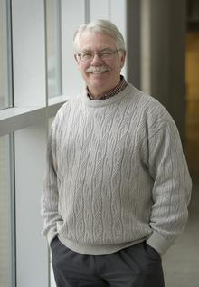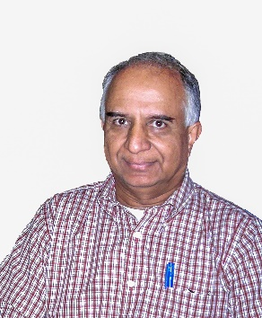
Prof. Maurice B. Dusseault
University of Waterloo
Prof. Derek Elsworth
Pennsylvania State University
Prof. Satya Harpalani
Southern Illinois University
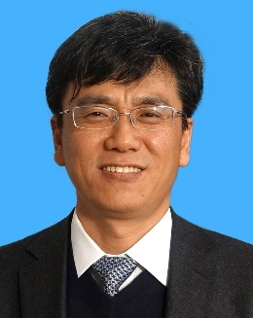
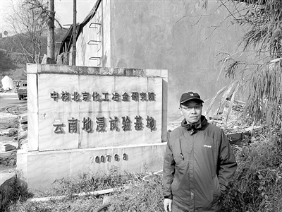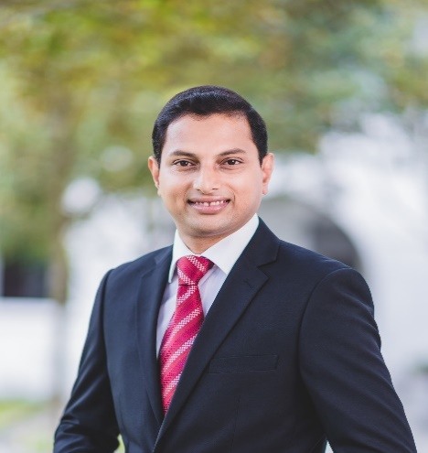
Prof. Jian-hua Li
Beijing Research Institute of Chemical Engineering and Metallurgy
Prof. Wei-guo Liang
Taiyuan University of Technology
Associate Prof. Praveen Linga
National University of Singapore
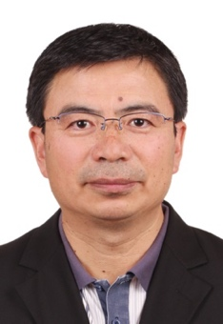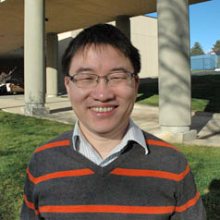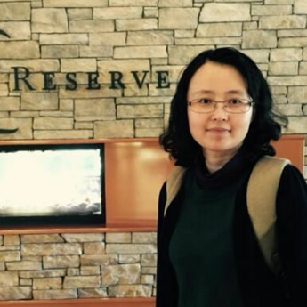
Prof. Ji-shan Liu
The University of Western Australia
Assistant Prof. Shi-min Liu
Pennsylvania State University
Prof. Shu-qin Liu
China University of Mining &Technology, Beijing
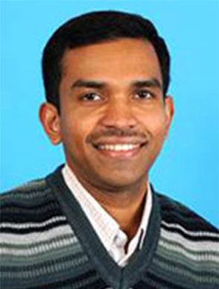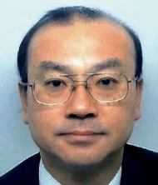
Prof. Ranjith P.Gamage
Monash University
Prof. Kyuro Sasaki
Kyushu University
Prof. Gui-ling Wang
Chinese Academy of Geological Sciences
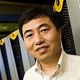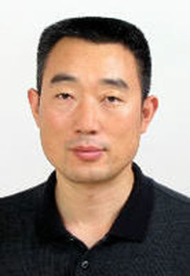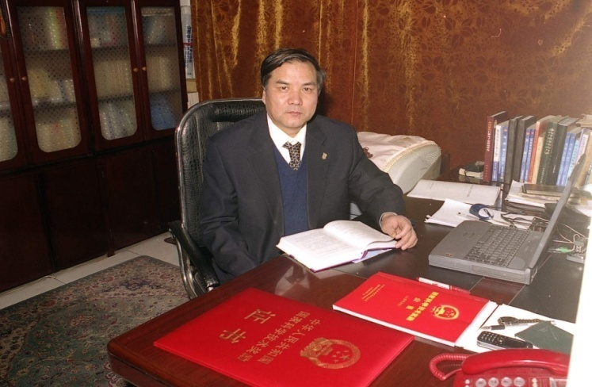
Prof. Hui-lin Xing
University of Queensland
Prof. Ai-xiang Wu
University of Science and Technology Beijing
Prof. Yang-sheng Zhao
Taiyuan University of Technology
Registration Fee
2400 CNY per person. 1200 CNY per person for students (Student photo ID needed).
Note: Above fee does not include hotel expense and visiting fee. Invoice will be issued by the hotel in the form of conference fee.
会务费
学术大会注册费：正式代表，2400元/人；学生代表，1200元/人（凭学生证）
备注：上述费用不含住宿费及考察费，发票由并州饭店以会务费形式开具。
Contact information
Zhi-gang Li 15234188639
Hao-jie Lian 15235205389
Zhi-qin Kang 13068003931
Zi-jun Feng 15135140825
E-mail：imdpim@hotmail.com
Mailing address: 18 Xinkuangyuan Road, Institute of Mining Technology, Taiyuan University of Technology, Taiyuan, 030024, China
联系人及联系方式：
李治刚 15234188639
廉浩杰 15235205389
康志勤 13068003931
冯子军 15135140825
大会E-mail：imdpim@hotmail.com
通讯地址：山西省太原市新矿院路18号，太原理工大学采矿工艺研究所，邮编：030024
Important Time
Abstract submission deadlines: July 25, 2018
Full paper submission deadlines: August 15, 2018
Conference Receipt deadlines: July 25, 2018
重要时间节点：
论文摘要截止时间：2018-7-25
论文全文截止时间：2018-8-15
会议回执截止时间：2018-7-25
Accommodation and transportation route
1. Conference Hotel
Hotel | Room type | Price
Bingzhou Hotel | StandardRoom | 460CNY per night
Bingzhou Hotel | QueenRoom | 460CNY per night
Note:organization committeemay make appropriate adjustments according to the hotel room reservation.
Hotel location: No.118 Yingze Street,Taiyuan,Shanxi, China
Hotel Tel: 0351-8821188
2.TransportationRoute
●Taiyuan Wusu airport to hotel
Take taxi to the Bingzhou Hotel(about 30 minutes, 60 CNY). Or take the airport bus line 1 and get off at Sanjin International HotelStop (15 CNY), then walk westward to the Bingzhou Hotel.
●Train to hotel
(1) Taiyuan Station to hotel: Walk about 200 meters from the exit to the south of Yingze Street, then take the busNo. 1, 6, 10, or 866 and get off at the Bingzhou Hotel Stop (the second stop). Or take taxi (about 8 CNY) to the Bingzhou Hotel.
(2) Taiyuan South Station (High SpeedRail Station to hotel): Take the bus No. 902, 901, or 901 and get off at Guangchang Stop, then walk about 360 meters northward to the Bingzhou Hotel. Or take the bus no. 502 (Night Shuttle) and get off at the BingzhouHotel Stop. Or take taxi (about 50 CNY) to the Bingzhou Hotel.
3. Special Reminder
1) Please send us the receipt to the Email Address imdpim@hotmail.com before July 25,2018 for all potential attendees, which will facilitate us arrangingthe reports, hotel, and other related matters.
2) After the conference, there is a chance tovisit the State Key Laboratory of Co-mining of Coal and CBM (Jincheng, Shanxi).
3) Taiyuan is the capital and largest city of Shanxi province in North China. Throughout its long history(2500 years), it was the capital or provisional capital of many dynasties in China, hence the name Lóngchéng ("Dragon City"). Taiyuan is abundant in natural resources such as coal, iron, silica, bauxite, limestone, copper, gold and so on.
大会住宿、交通及联系方式
1.大会宾馆与住宿宾馆
宾馆 | 房型 | 房价
并州饭店 | 标准间 | 460元
并州饭店 | 大床房 | 460元
报到时会务组会根据宾馆房间预订情况进行适当调整，请予谅解。
并州饭店地址：迎泽大街118号，联系电话：0351-8821188
2.交通路线
●飞机
太原武宿机场：出租车（约60元）行程约30分钟；或乘机场大巴1号线在三晋国际饭店（15元）下，向西步行至并州饭店。
●火车
（1）太原站：出站口步行200米至迎泽街南乘坐（1路、6路，10路,866路）公交至并州饭店下车（从太原站至并州饭店共计两站路）；或出租车（约8元））至并州饭店。
（2）太原南站（高铁站）：乘坐902/901/901支路公交至广场站下车，向北步行约360米至并州饭店；或乘坐502（夜间班车）至并州饭店下；或出租车（约50元）行程约25分钟。
3. 特别提醒
1）所有参加本次会议的参会代表，请务必将回执于7月25日之前返回（电子邮件发送至：imdpim@hotmail.com），方便会务组及时安排报告及住宿等相关事宜。
2）会后安排赴煤与煤层气共采国家重点实验室（山西晋城）考察。
3) 太原是华北地区山西省的省会和最大城市。2500多年来，它是中国许多王朝的都城或临时都城，故名“龙城”。太原自然资源丰富，如煤、铁、硅石、铝土矿、石灰岩、铜、金等。

The receipt of IMDPIM 2018
(September 18th-20th,2018, Taiyuan, Shanxi Province)
Name： Gender： Title： Position：
Employer： Number of participants：
Mailing address： Postal code：
Tel： Phone：E-mail：
Paper title submitted：
Attendance：□Oral presentation□Visiting the State Key Laboratory
(Please type “√” in the appropriate box, if you want to make a oral presentation and/or visit the State Key Laboratory)

Hotel Reservation (Please type “√” in the appropriate box)

Hotel | Room Type | Price | Quantity | Check-in date | Check-out date
Bingzhou Hotel | □Double bed | 460CNY
Bingzhou Hotel | □Queenbed | 460CNY
Note:organization committee will make appropriate adjustments according to the hotel room reservation.

第一届原位改性采矿国际研讨会会议回执
(2018年9月18～20日，山西省太原市)
姓名： 性别： 职称： 职务：
工作单位： 参会人数： 人
通讯地址： 邮编：
电 话： 手机： E-mail：
提交论文题目：
出席大会：□是否做报告 □是否参加国家重点实验室考察
（若是，请在相应的框内打“√”）

住宿预定（请在相应的框内打“√”）

住宿地点 | 房间类型 | 价 格 | 数 量 | 住宿时间
并州饭店 | □标准间 | 460元 | 间 | 日～ 日
并州饭店 | □大床房 | 460元 | 间 | 日～ 日
注：报到时会务组根据宾馆房间预订情况进行适当调整，请予谅解。

